Analysis of bootcamp survey
Rick Gilmore
2017-08-17 12:02:51
Table of Contents

Goals
- Download and clean data from 2017 R Bootcamp Survey
- Visualize data
- Prepare reports in ioslides_presentation, pdf_document, and word_document formats

Preliminaries
Load required packages.
library(tidyverse)
library(googlesheets)

Load data and examine
The survey data are stored in a Google Sheet. We'll use the googlesheets package to open it and create a data frame. Documentation about the package can be found here.
There are some idiosyncrasies in using the googlesheets package in an R Markdown document because it requires interaction with the console, so I created a separate R script, Get_bootcamp_googlesheet.R to extract the survey data. If you try to execute the next chunk, it may give you an error, or it may ask you to allow googlesheets to access information in your Google profile.
# Set eval=FALSE so I can render non-notebook formats
source("../R/Get_bootcamp_googlesheet.R")
This script downloads the data file saves it to a CSV under data/survey.csv.We can then load this file.
I also created a test data file, data/survey-test.csv so I could see how everything worked before y'all filled out your responses. The R/Make_test_survey.R file shows how I did this. It's a great, reproducible practice to simulate the data you expect, then run it through your pipeline.

# Created test data set for testing.
# survey <- read_csv("../data/survey-test.csv")
# Or choose data from respondents
survey <- read_csv("../data/survey.csv")
## Parsed with column specification:
## cols(
## Timestamp = col_character(),
## `Your current level of experience/expertise with R` = col_character(),
## `Your enthusiasm for Game of Thrones` = col_integer(),
## `Age in years` = col_integer(),
## `Preferred number of hours spent sleeping/day` = col_character(),
## `Favorite day of the week` = col_character(),
## `Are your data tidy?` = col_character()
## )
survey
## # A tibble: 39 x 7
## Timestamp `Your current level of experience/expertise with R`
## <chr> <chr>
## 1 <NA> <NA>
## 2 8/13/2017 23:29:24 some
## 3 8/14/2017 12:01:12 some
## 4 8/15/2017 12:42:09 some
## 5 8/15/2017 17:13:08 none
## 6 8/15/2017 19:03:40 limited
## 7 8/15/2017 23:36:07 some
## 8 8/15/2017 23:45:05 limited
## 9 8/16/2017 0:26:01 pro
## 10 8/16/2017 1:09:44 none
## # ... with 29 more rows, and 5 more variables: `Your enthusiasm for Game
## # of Thrones` <int>, `Age in years` <int>, `Preferred number of hours
## # spent sleeping/day` <chr>, `Favorite day of the week` <chr>, `Are your
## # data tidy?` <chr>
The str() or 'structure' command is also a great way to see what you've got.
str(survey)
## Classes 'tbl_df', 'tbl' and 'data.frame': 39 obs. of 7 variables:
## $ Timestamp : chr NA "8/13/2017 23:29:24" "8/14/2017 12:01:12" "8/15/2017 12:42:09" ...
## $ Your current level of experience/expertise with R: chr NA "some" "some" "some" ...
## $ Your enthusiasm for Game of Thrones : int NA 10 10 10 10 10 10 3 9 10 ...
## $ Age in years : int NA 28 22 24 28 24 23 25 37 25 ...
## $ Preferred number of hours spent sleeping/day : chr NA "8!!!" "7" "10" ...
## $ Favorite day of the week : chr NA "Friday" "Friday" "Saturday" ...
## $ Are your data tidy? : chr NA "Yes" "That's a personal question" "No" ...
## - attr(*, "spec")=List of 2
## ..$ cols :List of 7
## .. ..$ Timestamp : list()
## .. .. ..- attr(*, "class")= chr "collector_character" "collector"
## .. ..$ Your current level of experience/expertise with R: list()
## .. .. ..- attr(*, "class")= chr "collector_character" "collector"
## .. ..$ Your enthusiasm for Game of Thrones : list()
## .. .. ..- attr(*, "class")= chr "collector_integer" "collector"
## .. ..$ Age in years : list()
## .. .. ..- attr(*, "class")= chr "collector_integer" "collector"
## .. ..$ Preferred number of hours spent sleeping/day : list()
## .. .. ..- attr(*, "class")= chr "collector_character" "collector"
## .. ..$ Favorite day of the week : list()
## .. .. ..- attr(*, "class")= chr "collector_character" "collector"
## .. ..$ Are your data tidy? : list()
## .. .. ..- attr(*, "class")= chr "collector_character" "collector"
## ..$ default: list()
## .. ..- attr(*, "class")= chr "collector_guess" "collector"
## ..- attr(*, "class")= chr "col_spec"
Clearly, we need to do some cleaning before we can do anything with this.
Let's start by renaming variables.
names(survey) <- c("Timestamp",
"R_exp",
"GoT",
"Age_yrs",
"Sleep_hrs",
"Fav_day",
"Tidy_data")
# complete.cases() drops NAs
survey <- survey[complete.cases(survey),]
survey
## # A tibble: 38 x 7
## Timestamp R_exp GoT Age_yrs Sleep_hrs Fav_day
## <chr> <chr> <int> <int> <chr> <chr>
## 1 8/13/2017 23:29:24 some 10 28 8!!! Friday
## 2 8/14/2017 12:01:12 some 10 22 7 Friday
## 3 8/15/2017 12:42:09 some 10 24 10 Saturday
## 4 8/15/2017 17:13:08 none 10 28 9 Saturday
## 5 8/15/2017 19:03:40 limited 10 24 9 Saturday
## 6 8/15/2017 23:36:07 some 10 23 6-7 Friday
## 7 8/15/2017 23:45:05 limited 3 25 8 Friday
## 8 8/16/2017 0:26:01 pro 9 37 7 Friday
## 9 8/16/2017 1:09:44 none 10 25 9 Saturday
## 10 8/16/2017 8:51:05 limited 1 23 7.5 Thursday
## # ... with 28 more rows, and 1 more variables: Tidy_data <chr>
Now, lets make sure we have numbers where we expect them. That person who really likes 8 hours ("8!!!") is a problem (for me, not them).
survey$Sleep_hrs <- readr::parse_number(survey$Sleep_hrs)
survey
## # A tibble: 38 x 7
## Timestamp R_exp GoT Age_yrs Sleep_hrs Fav_day
## <chr> <chr> <int> <int> <dbl> <chr>
## 1 8/13/2017 23:29:24 some 10 28 8.0 Friday
## 2 8/14/2017 12:01:12 some 10 22 7.0 Friday
## 3 8/15/2017 12:42:09 some 10 24 10.0 Saturday
## 4 8/15/2017 17:13:08 none 10 28 9.0 Saturday
## 5 8/15/2017 19:03:40 limited 10 24 9.0 Saturday
## 6 8/15/2017 23:36:07 some 10 23 6.0 Friday
## 7 8/15/2017 23:45:05 limited 3 25 8.0 Friday
## 8 8/16/2017 0:26:01 pro 9 37 7.0 Friday
## 9 8/16/2017 1:09:44 none 10 25 9.0 Saturday
## 10 8/16/2017 8:51:05 limited 1 23 7.5 Thursday
## # ... with 28 more rows, and 1 more variables: Tidy_data <chr>
Looks good. Let's save that cleaned file so we don't have to do this again.
write_csv(survey, path="../data/survey_clean.csv")
We may want to make the R_exp variable ordered.
(survey_responses <- unique(survey$R_exp))
## [1] "some" "none" "limited" "pro"
This shows us the different survey response values.
survey$R_exp <- ordered(survey$R_exp, levels=c("none",
"limited",
"some",
"lots",
"pro"))

Visualization
Now, we follow Mike Meyer's advice: "Plot your data!"

Descriptive plots
R_exp_hist <- survey %>%
ggplot() +
aes(x=R_exp) +
geom_histogram(stat = "count") # R_exp is discrete
## Warning: Ignoring unknown parameters: binwidth, bins, pad
R_exp_hist
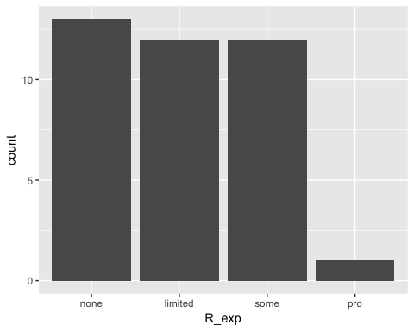
Distribution of prior R experience
Sleep_hrs_hist <- survey %>%
ggplot() +
aes(x=Sleep_hrs) +
geom_histogram() # Sleep_hrs is continuous
Sleep_hrs_hist
## `stat_bin()` using `bins = 30`. Pick better value with `binwidth`.
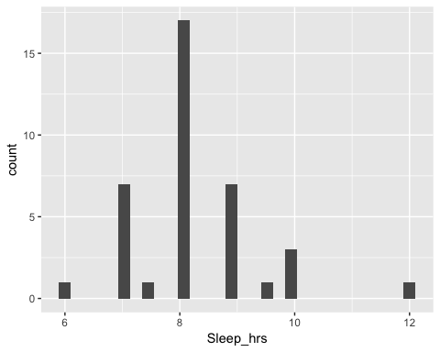
Distribution of preferred sleep hrs/day
Got_hist <- survey %>%
ggplot() +
aes(x=GoT) +
geom_histogram()
Got_hist
## `stat_bin()` using `bins = 30`. Pick better value with `binwidth`.
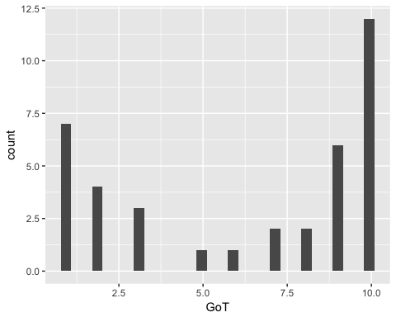
Distribution of GoT Enthusiasm
Looks like we are of two minds about GoT.
Does R experience have any relation to GoT enthusiasm?
GoT_vs_r_exp <- survey %>%
ggplot() +
aes(x=GoT, y=Age_yrs) +
facet_grid(. ~ R_exp) +
geom_point()
GoT_vs_r_exp
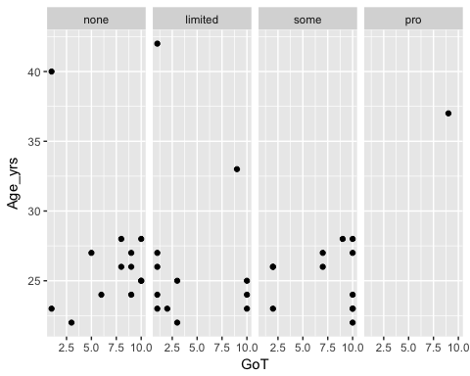
tidy_hist <- survey %>%
ggplot() +
aes(x=Tidy_data) +
geom_histogram(stat = "count")
## Warning: Ignoring unknown parameters: binwidth, bins, pad
tidy_hist
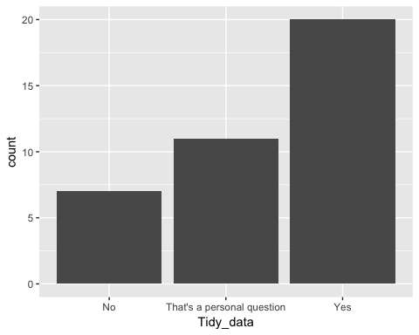

Analysis
I could use a document like this to plan out my analysis plan before I conduct it. If I used simulated data, I could make sure that my workflow will run when I get real (cleaned) data. I could even preregister my analysis plan before I conduct it. That doesn't preclude later exploratory analyses, but it does hold me and my collaborators accountable for what I predicted in advance.

Notes
Notice that I sometimes put a label like got-vs-r-exp in the brackets for a given 'chunk' of R code. The main reasons to do this are:
- It sometimes makes it easier to debug your code.
- In some cases, you can have this 'chunk' name serve as the file name for a figure you generate within a chunk.
- In a bit, we'll see how these chunk names are useful for making tables, figures, and equations that generate their own numbers.

