PSY 511.001
Fall 2019

Quiz 1
(10 points)

Instructions

Type answers to the questions below in the spaces provided using complete sentences. If you run out of room for an answer, continue on the back of the page. Save a copy of the quiz using the following naming format: PSY511.001-2019-quiz-01-LASTNAME.docx, substituting your last name for LASTNAME.

Please take no more than 30 min to complete this quiz, and please do not use any resources other than your own memory.

Bring a printed copy to class on Friday, September 27, 2019. If you will miss class, you may put your quiz in my mailbox.

Questions

- Describe the main components of the central nervous system associated with the lateral ventricles.

- What region(s) of the brain is/are associated with the cerebral aqueduct?

- What kind of imaging technique is diffusion tensor imaging (DTI)? What does it provide information about?

- Which forebrain structure controls ingestion, defense, and reproductive behavior, and where is it located?

- Using the figure below, label the planes of section and as many of the following directional terms as you are able to use: anterior/posterior; superior/inferior; medial/lateral; dorsal/ventral.

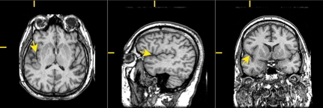

- What are the two main classes of myelin-producing glial cells, and where are they found?

- What ion(s) involved in the resting and action potentials is most heavily concentrated inside the neuron?

- What function does the blood/brain barrier serve and what makes up the barrier?

- Functional MRI (fMRI) is considered an indirect measure of neuronal activity because...

- Describe at least two ways that neurons differ from other cells in the body.

Bonus

- What technique for recording neural activity has especially high spatial and temporal resolution?

- Where in a neuron would one find Nodes of Ranvier? What purpose do they serve?

