PSY 511.001
Fall 2020

Quiz 1
(10 points + 2 optional bonus points)

Instructions

Type answers to the questions below in the spaces provided using complete sentences. Most answers should be a few sentences in length. You may add a simple diagram if it helps you, but this is not required. Save a copy of the quiz using the following naming format: PSY511.001-2020-quiz-01-LASTNAME.docx, substituting your last name for LASTNAME.

Please take no more than 45 min to complete this quiz, and please do not use any resources other than your own memory.

Email a copy to me at rog1@psu.edu by 2:00 PM on Thursday, October 1, 2020.

Questions

- Describe the concentration and electrostatic gradients that act on K+ in the neuron at rest.

- Describe the concentration and electrostatic gradients that act on Na+ in the neuron at rest.

- What event(s) trigger the rising phase of the action potential?

- The movement of which ion causes the falling phase of the action potential? Which direction does this ion move during the falling phase, and why?

- Describe the main components of the central nervous system associated with the lateral ventricles.

- What kind of imaging technique is electroencephalography (EEG)? What does it provide information about?

- Using the figure below, label the planes of section and as many of the following directional terms as you are able to use: anterior/posterior; superior/inferior; medial/lateral; dorsal/ventral.

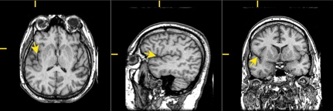

- What are the two main classes of myelin-producing glial cells, and where are they found?

- Functional MRI (fMRI) is considered an indirect measure of neuronal activity because...

- Describe at least two ways that neurons differ from other cells in the body.

Bonus

- What technique for recording neural activity has especially high spatial and temporal resolution?

- Where in a neuron would one find Nodes of Ranvier? What purpose do they serve?

