260-2017-04-24-speed-lab
PSYCH 260.003
2017-04-24 09:52:34

Today's topic
- Measuring the speed of nervous system conduction
- And, a tiny lesson in open, transparent, reproducible data science

Question
- How fast does the nervous system conduct information?
- Prior evidence
  - Proprioception vs. touch
- Why do we care?

Prediction
We predict that the speed of conduction will be ...

Scheme
- Speed = Distance/Time
- Chain of participants to make distance larger
  - If typical person ~ 1.5 m, then
  - at s=30 m/s, t = d/s -> 1.5/30 = 0.05 secs.

Condition 1 (ankle)
- Squeeze ankle
- ankle_shoulder + shoulder_brain + brain_decide + brain_shoulder + shoulder_hand

Condition 2 (shoulder)
- Squeeze shoulder
- shoulder_brain + brain_decide + brain_shoulder + shoulder_hand
- Condition 1 - Condition 2
- ankle_shoulder + shoulder_brain + brain_decide + brain_shoulder + shoulder_hand

Measure
- sum(ankle_shoulder) for all participants -> Distance
- mean(time(Condition 1)) - mean(time(Condition 2)) -> Time
- Speed = Distance/Time

Materials
- Stop watch
- Tape measure

Decisions
- Same hand or dominant?
- Alternate ankle/shoulder or one condition before the other?
- How many trials?
  - Fixed number?
  - When reach asymptote?

Data files
- Data file with body measurements
  - participant, ankleshoulder (cm)
- Data file with reaction times
  - trial {1...n}, condition {ankle, shoulder}, time (s)

# Load R packages
library("googlesheets")
suppressPackageStartupMessages(library("dplyr"))
suppressPackageStartupMessages(library("ggplot2"))

Measuring distance
psych260 <- gs_title("psych-260-spring-2017")
## Sheet successfully identified: "psych-260-spring-2017"
psych260 %>%
gs_read(ws = "distance") ->
distance
## Accessing worksheet titled 'distance'.
##
Downloading: 130 B
Downloading: 130 B
Downloading: 130 B
Downloading: 130 B
## No encoding supplied: defaulting to UTF-8.
dist.hist <- ggplot(data = distance, aes(x=ankleshoulder)) +
geom_histogram(bins = 5)

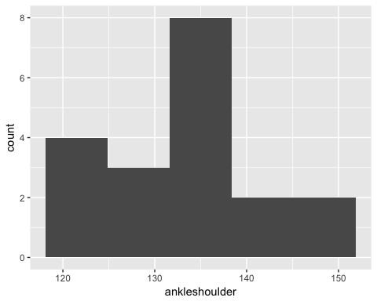

Sum distance
with(distance, summary(ankleshoulder))
## Min. 1st Qu. Median Mean 3rd Qu. Max.
## 122.0 125.5 132.0 133.2 137.5 149.0
# Calculate sum
dist.sum = with(distance, sum(ankleshoulder))
The total distance is 2531 cm.

Measuring time
psych260 %>%
gs_read(ws = "time") ->
time
## Accessing worksheet titled 'time'.
##
Downloading: 110 B
Downloading: 110 B
Downloading: 120 B
Downloading: 120 B
Downloading: 120 B
Downloading: 120 B
## No encoding supplied: defaulting to UTF-8.
# Plot data
time.plot = ggplot(data = time, aes(x=trial, y=time, color=condition)) +
geom_point() +
geom_line()

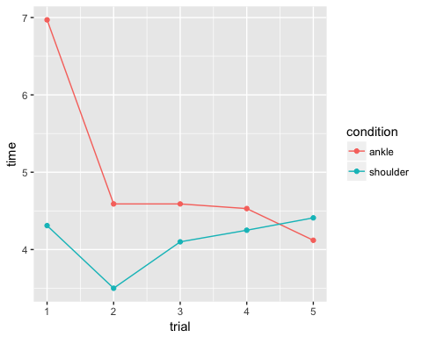

Calculate time difference
time %>%
filter(condition == "ankle") ->
ankle.times
time %>%
filter(condition == "shoulder") ->
shoulder.times
time.diff <- data_frame(trial=unique(time$trial),
time=ankle.times$time - shoulder.times$time)
time.diff.plot = ggplot(data = time.diff, aes(x=trial, y=time)) +
geom_point() +
geom_line()

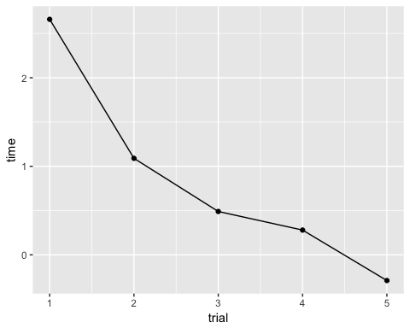

Calculating speed
time.diff$speed <- (dist.sum)*.01/time.diff$time
speed.hist <- ggplot(data = time.diff, aes(x=speed)) +
geom_histogram(bins = 5)

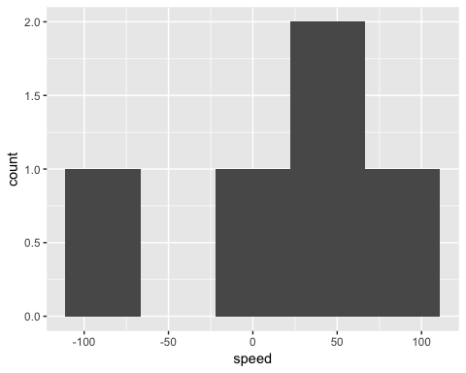

Plot time series of speeds
speed.plot <- ggplot(data = time.diff, aes(x=trial, y=speed)) +
geom_point() +
geom_line()

speed.plot
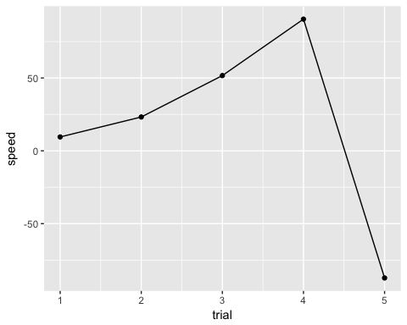

Summarizing findings
- We tested the mean speed of neural propagation in a sample of n=19 college-age adults.
- The mean speed of neural propagation over 5 trials was 17.5 m/s with a range of [-87.28, 90.39] m/s.
- These findings are/are not generally in accord with values we would expect from the literature.

Limitations

How to replicate/extend

Contributors

Resources
This document was prepared in RStudio 1.0.36 on 2017-04-24 09:52:39.
sessionInfo()
## R version 3.3.2 (2016-10-31)
## Platform: x86_64-apple-darwin13.4.0 (64-bit)
## Running under: OS X El Capitan 10.11.6
##
## locale:
## [1] en_US.UTF-8/en_US.UTF-8/en_US.UTF-8/C/en_US.UTF-8/en_US.UTF-8
##
## attached base packages:
## [1] stats graphics grDevices utils datasets methods base
##
## other attached packages:
## [1] ggplot2_2.2.1 dplyr_0.5.0 googlesheets_0.2.1
##
## loaded via a namespace (and not attached):
## [1] Rcpp_0.12.10 xml2_1.1.1 knitr_1.15.1 magrittr_1.5
## [5] hms_0.3 munsell_0.4.3 colorspace_1.3-2 R6_2.2.0
## [9] httr_1.2.1 stringr_1.2.0 plyr_1.8.4 tools_3.3.2
## [13] grid_3.3.2 gtable_0.2.0 DBI_0.6-1 htmltools_0.3.5
## [17] openssl_0.9.6 yaml_2.1.14 lazyeval_0.2.0 assertthat_0.2.0
## [21] rprojroot_1.2 digest_0.6.12 tibble_1.3.0 readr_1.1.0
## [25] purrr_0.2.2 rsconnect_0.7 curl_2.5 evaluate_0.10
## [29] rmarkdown_1.4 labeling_0.3 stringi_1.1.5 cellranger_1.1.0
## [33] scales_0.4.1 backports_1.0.5 jsonlite_1.4

